Test Project Module 2 / 競賽試題2
(Editorial) / （編輯設計）

WSC2013_TP40_M2_actual_EN

Submitted by: Group 2

Arnold Sandjaja ID
Christoph Elmecker AT
Hee Min Sa KR
Hjortur Gudnason IS
Katsuji Hirata JP
Michel Bulon CA
Nuno Viana PT

Introduction to test project documentation / 競賽試題說明文件

Contents / 內容
This Test Project proposal consists of the following documentation/files:

- WSC2013_TP40_MOD02_actual_TP_EN.doc
- WSC2013_TP40_MOD2_PRE_EN_images (Images Folder)
- WSC2013_TP40_MOD2_PRE_EN_ATTAC_logo (ATTAC Logo Folder)
- WSC2013_TP40_MOD2_PRE_EN_BARCODE.eps
- WSC2013_TP40_MOD2_PRE_EN_TEXT_FILES.docx

這個競賽試題包含以下文件與檔案：
- WSC2013_TP40_MOD02_actual_TP_EN.doc
- WSC2013_TP40_MOD2_PRE_EN_images (圖片資料夾)
- WSC2013_TP40_MOD2_PRE_EN_ATTAC_logo (ATTAC公司標誌資料夾)
- WSC2013_TP40_MOD2_PRE_EN_BARCODE.eps
- WSC2013_TP40_MOD2_PRE_EN_TEXT_FILES.docx

Introduction / 說明

Project :
Task 1: Create a masthead for the magazine with the name “SPANNER in the works” for the organisation ATTAC
Task 2: “Design a magazine SPANNER in the works

試題：
任務一：為ATTAC這個協會設計一個雜誌標題，名為「SPANNER in the works」
任務二：設計一本名為SPANNER in the works的雜誌

Description : / 說明：
ATTAC is an international organization involved in the alter-globalization movement. We oppose neo-liberal globalization and develop social, ecological, and democratic alternatives so as to guarantee fundamental rights for all. Specifically, we fight for the regulation of financial markets, the closure of tax havens, the introduction of global taxes to finance global public goods, the cancellation of the debt of developing countries, fair trade, and the implementation of limits to free trade and capital flows.

ATTAC是一個專注於國際動態議題的國際性協會。我們反對新的國際自由主義以及發展社會、生態、外交替代，以保障所有人的基本人權。尤其，我們為經濟市場的限制抗爭、終止逃稅天堂、引介國際稅收來援助國際公眾的貨品、取消發展中國家的債款、公平交易，以及限制履行自由交易和外資流動。

A word on our history
The ‘Association pour la Taxation des Transactions financière et l'Aide aux Citoyens’ (Association for the Taxation of financial Transactions and Aid to Citizens) was founded in France in December 1998 after the publication in the Monde Diplomatique of an editorial entitled ‘Désarmer les marchés’ (Disarm the markets) that launched the notion of creating an association to promote the Tobin tax.

關於我們的歷史
這個「Association pour la Taxation des Transactions financière et l'Aide aux Citoyens」（金融課稅處理和協助市民協會）1998年12月在Monde Diplomatique發表一篇名為「Désarmer les marchés」（緩和市場）的社論後成立於法國。這促使了一個概念來設立一個協會宣傳Tobin tax（托賓稅）。

An international organization
The organization expanded very rapidly around the world with an ATTAC network around an international charter set up in 1999. Today, the association is active in some 40 countries, with over a thousand local groups and hundreds of organizations supporting the network.

一個國際性組織
這個組織在世界上擴張非常的快速，透過ATTAC網絡的國際特權，創立於1999。今日，這個協會活躍在40多個國家中，有超過一千個當地團隊和數以百計的組織支持這個網絡。

Target market: / 目標市場：

Young people between 16-35 years who are interested in the alter-globalization movement, which emphasizes values such as democracy, social and economic justice, environmental protection and human rights as an alternative to the current globalism.
They are either a member of ATTAC or are thinking of joining.

在16-35歲之間的年輕人，對多變的國際議題有興趣，尤其是外交、社會和生態正義、環境保護和人權，都視為選擇性的當今全球性干預政策。
他們可以是ATTAC的會員或是想要加入的人。

Description of project and tasks / 競賽試題與任務說明

TASK 1 / 任務一
Creation of a masthead
- Create a masthead and use the name “SPANNER” with the subhead “in the works”.
- You are free to add any elements or illustrations of your own to the masthead.

雜誌標題的設計
‧設計一個雜誌標題，名為「SPANNER」，以及副標題「in the works」。
‧你可以自由加入任何元素或插畫在你的標題設計上。

Technical specifications

Trapping : 0.35 pts (if necessary).
Printing : Sheet-fed offset.

技術規格
補漏白 ：0.35 pts (如需要)
印刷 ：張頁式平版印刷

You must deliver
- 1 version of the masthead in exactly 2 PMS C colours in eps or AI format
- 1 version of the masthead converted to CMYK in eps or AI format
- 1 version of the masthead in Adobe RGB (1998) for the web in JPG format
- 1 file PDF/X-4:2008 file of the masthead in CMYK on one single A4 sheet at both 15cm wide and 4cm wide (without any marks, bleed or colour bars)
- 1 Printout masthead and mounted on cardboard from the CMYK PDF/X-4:2008 file

你必須繳交
‧一個雜誌標題設計：2色PMS C色彩，eps或AI格式
‧一個雜誌標題設計：轉為CMYK，eps或AI格式
‧一個雜誌標題設計：Adobe RGB (1998) 存為網路格式JPG的檔案
‧一個PDF/X-4:2008的雜誌標題設計檔案，CMYK，15cm寬和4cm寬各一個，印在同一張A4上（不要任何標記、出血或色表）。
‧一個雜誌標題設計輸出，從CMYK、PDF/X-4:2008的檔案輸出，並裱貼於展板上。

TASK 2 / 任務二
Magazine Design
- Create a design for the front cover, back cover and spine
- Create a design for page 3 of the magazine accommodating for the die-line of the cover

- Create two spreads for the magazine (pages 8&9, 10&11)
- Include required text in the magazine (WSC2013_TP40_MOD2_PRE_EN_TEXT_FILES.docx)

- You must create a die-line for the cover
- The inside pages of the magazine will be printed in 2 colours (Black and PMS 7549 C)
- Include the barcode with a white background; do not resize it and make sure it’s 100% black (WSC2013_TP40_MOD2_PRE_EN_BARCODE.eps)
- You may create your own illustrations

雜誌設計
- 設計一個封面、封底和書背
- 為第三頁設計，必須與封面的刀模有相搭配
- 為雜誌設計兩個跨頁（第8-9頁、第10-11頁）
- 包含雜誌要求的文案（WSC2013_TP40_MOD2_PRE_EN_TEXT_FILES.docx）
- 你必須為封面設計一個刀模
- 雜誌內頁會用雙色印刷（黑色和PMS 7549 C）
- 包含有一個白底的條碼；不可更改尺寸，並確保一定是100%黑色（WSC2013_TP40_MOD2_PRE_EN_BARCODE.eps）
- 你可以設計自己的插圖

Front Cover must include:
- Masthead
- Selling Line
- Logo %ATTAC

- Main cover line
- image (at least one)
- 3
- Cover lines
- Dateline
- Barcode
- Splash/ Seal/ Flash/ Slashes

- Any other artwork you deem necessary
封面必須包含：
‧雜誌標題
‧賣點的文字
‧ATTAC公司標誌：%ATTAC
‧主要封面的文字
‧圖片（至少一張）
‧三個封面文字
‧日期
‧條碼
‧宣傳/蓋印/訊息/修訂
‧任何其他你覺得需要的設計

Back Cover must include:
- The logo at exactly 35mm wide
- Text for back cover
- Any other artwork you deem necessary
封底必須包含：
‧標誌為35mm寬
‧封底的文案
‧任何其他你覺得需要的設計

Spine must include:
- Text for spine
書背必須包含：
‧書背的文案

Inside pages of the magazine must include:

- Page 3: Single page must display an editorial with titles, texts, and caption (at least 1 image and any other artwork you consider necessary)
- Page 8-9: One spread must display the cover story and some images of the cover story (at least 2 images) with titles, texts, captions, 1 table and 1 infographic
- Page 10-11: One spread must display three short articles with titles, texts, and captions (at least 1 image for each article)

雜誌內頁需要包含：
‧第3頁：單面必須編排標題、文案、圖說（至少一張圖片以及其他你覺得需要的設計）
‧第8-9頁：一個跨頁必須編排封面故事和一些封面故事的圖片（至少兩張圖片）有標題、文案、圖說、一個圖表和一個信息設計
‧第10-11頁：一個跨頁必須編排三個短篇文章，有標題、文案、圖說（每一篇文章須至少一張圖片）

Technical specifications
Dimensions : A maximum page size of 190mm x 270mm (portrait) perfect bound with a 6 mm spine.
Paragraph Styles : Must be used for titles, body text, caption
Character Styles : Must be used for coverline, Dateline
Master Page Elements : Header/footer and page numbers
Bleed : 3 mm
Colours (Front, spine & Back cover) : CMYK, spot dieline

Colours (inside pages of magazine) : 2 colours (PMS 7549 C and Black)
Output ICC profile in PDF : ISO Web coated FOGRA28 /Total ink 300% (front & back Cover) 200% (inside pages of magazine)
Printing system : Heatset web offset
Dieline : Must be named “Dieline”, must be created as a spot colour and must overprint
Greyscale and colour images resolution : 262 to 350 PPI at 100% in InDesign
Bitmap images resolution : 800 to 1200 PPI at 100% in InDesign

技術規格
尺寸 ：最大尺寸190mm x 270mm（直式）膠裝於6 mm的書背
段落樣式 ：使用於標題、內文、圖說
文字樣式 ：使用於封面文字、日期
主版元素 ：頁眉/頁腳和頁碼
出血 ：3 mm
色彩（封面、書背和封底） ：CMYK、特別色刀模版
色彩（雜誌內頁） ：2個色彩（PMS 7549 C和黑色）
外掛PDF ICC色彩描述檔 ：ISO Web coated FOGRA28
油墨總印量300%（封面與封底），200%（雜誌內頁）
印刷系統 ：輪轉式平版印刷
刀模 ：必須命名為「Dieline」，必須設為特別色和疊印
灰階和彩色影像解析度 ：262 to 350 PPI，100%，在InDesign
點陣圖片解析度 ：800 to 1200 PPI，100%，在InDesign

You must deliver

• 1 final folder for archiving named with your competitor number_module1
(including native files, fonts, linked images, ICC profile and the press ready PDF/X1a file)
only files from this folder will be marked

• 2 final press ready PDF/X1a files (1 PDF for cover, spine and back cover; and 1 PDF for inside pages, including: bleed, crop marks, registration marks, fold marks — placed outside the bleed area, colour bars for CMYK, colour bar PMS C, dieline on a separate plate in the PDF, to be evaluated in the PDF file)

• 1 final printout untrimmed and mounted on cardboard : the front cover, spine and back cover with the die-line (printed as spreads). (including: bleed, crop marks, registration marks, fold marks — placed outside the bleed area, colour bars CMYK)

• 1 final printout of: the die-line (printed as spreads). (including:, crop marks, registration marks, fold marks — placed outside the bleed area)

• 1 final dummy/booklet trimmed to final size including:
- the front cover, spine, back cover printed as spreads
- 1 page printed as a single page (page 3)
- four pages printed as spreads (8-9 and 10-11)

你必須繳交
‧一個命名為你的競賽編號_module1的工作檔資料夾（包含原始檔案、字體、連結的圖片、ICC色彩描述檔和印刷準備的PDF/X1a檔案）只有放在這個資料夾的檔案會被評分
‧兩個最終印刷準備的PDF/X1a檔案（一個有封面、書背和封底的PDF檔案；一個有內頁的PDF檔案，包含出血、裁切標記、對版標記、摺線－放置於出血之外的範圍、CMYK的色表、PMS C的色表、刀模須在PDF檔案中分層，將以PDF檔案評分）
‧一個最終不裁切的輸出，並裱貼於展板：封面、書背和封底，包含刀模（印成跨頁）（包含出血、裁切標記、對版標記、摺線－放置於出血之外的範圍、CMYK的色表）
‧一個刀模版輸出：刀模（印成跨頁）（包含裁切標記、對版標記、摺線－放置於出血之外的範圍）
‧一個最終模擬冊子，裁切至實際大小包含：
‧封面、書背、封底，印成跨頁
‧一頁印成單獨一頁（第3頁）
‧四頁印成跨頁（第8-9頁和第10-11頁）

Instructions to the competitor / 競賽選手說明
Create a folder on your Desktop called YY_MODX (where YY represents the number of your workstation). This folder must include the following subfolders:

在你的桌面建立一個資料夾，命名為「YY_MODX」（YY代表你的工作台編號）
這個資料夾必須包含以下子資料夾：

- Original_folder: it should contain all the files used for the development of your project, properly organized (fonts, links, etc.).
- Final_folder: it should contain all the files you are supposed to deliver as required in the tasks (PDF, etc.).

1. Original_folder（原始_資料夾）：這個資料夾必須包含你的所有工作檔案、妥當的整理（字體、連結的圖檔等等）
2. Final_folder（最終_資料夾）：這個資料夾必須包含你為任務準備列印的檔案（PDF等等）

About image marking for the tasks:
The colour mode and file formats of your images will be evaluated in the press ready PDF files. The final resolution will be assessed in the InDesign file.

任務中對圖片的評分：
你的影像色彩模式和檔案格式將會在印刷準備的PDF檔案評分。最終解析度會於InDesign檔案中評分。

The JPG file format is NOT ACCEPTED for images; except for the web component of the logo in RGB for the web.
Only the following file formats are acceptable .TIF / .EPS / .AI / .PSD / DSC 2.0

影像檔案不接受JPG檔案格式；除了供網路使用的網路格式的RGB標誌
只有以下檔案格式被接受.TIF / .EPS / .AI / .PSD / DSC 2.0

About final design marking for the catalogue:
The task must be created in a page layout program (Adobe InDesign).
Images must not be embedded or placed in Adobe Illustrator or embedded in InDesign

關於最終雜誌設計的評分：
這個任務必須於編排軟體進行設計（Adobe InDesign）
影像不可以嵌入或置入Adobe Illustrator或InDesign

Any file saved out of its respective folder WILL NOT BE EVALUATED.

任何儲存在這個資料夾之外的檔案將不會被評分

Marking scheme / 評分標準
A | Creative process / 創意過程 |  | Subjective /2
A.1 | Idea and originality (masthead, dieline and magazine) |  | 1.00
A.2 | Understanding the target market (masthead, dieline and magazine) |  | 0.50
A.3 | Unity and relationship (masthead and magazine) |  | 0.50
A.1  A.2  A.3 | 概念和原創性（雜誌標題設計、刀模和雜誌）  了解目標市場（雜誌標題設計、刀模和雜誌）  一致性與關係（雜誌標題設計和雜誌） |  | 1.00  0.50  0.50
B | Final design / 最終設計 |  | Subjective /8
B.1 | Quality of the visual composition (masthead and magazine layout) |  | 1.00
B.2 | Impact of the design (masthead, magazine layout and usage of font) |  | 1.00
B.3 | Quality of the typography for the masthead |  | 1.00
B.4 | Quality of the typography for the magazine |  | 2.00
B.5 | Quality of the colours for the masthead |  | 0.75
B.6 | Quality of the colours for the magazine |  | 1.25
B.7 | Quality of the design & originality of other elements (choice of page size & master page elements) |  | 0.50
B.8 | Quality of the infographic (magazine page 8 or 9) |  | 0.50
B.1  B.2  B.3  B.4  B.5  B.6  B.7  B.8 | 視覺構成的品質（雜誌標題設計和雜誌編排）  設計衝擊力（雜誌標題設計、雜誌編排和字體運用）  雜誌標題設計字體的品質  雜誌設計的品質  雜誌標題設計色彩的品質  雜誌設計色彩的品質  設計與其他原創性元素的品質（選擇的尺寸大小和主版的元素）  信息設計的品質（雜誌內頁：第8頁或第9頁） |  | 1.00  1.00  1.00  2.00  0.75  1.25  0.50  0.50
C | Computer usage / 電腦應用 |  | Objective /4
C.1 | Resolution of linked images as specified in magazine marked in InDesign |  | 0.50
C.2 | Colour mode of linked images as specified in magazine |  | 0.75
C.3 | Logo and barcode dimensions as required in the task |  | 0.25
C.4 | Use of paragraphs styles & master pages in layout as specified in magazine |  | 1.00
C.5 | Use of Character Styles in layout as specified in magazine |  | 0.25
C.6 | Final dimensions of layout as specified in all tasks (masthead, spine, inside pages) |  | 0.50
C.7 | All required text is present (masthead and inside pages) |  | 0.50
C.8 | All required elements are present in both tasks |  | 0.25
C.1  C.2  C.3  C.4  C.5  C.6  C.7  C.8 | 在InDesign製作要求的連結影像解析度  雜誌設計要求的連結影像色彩模式  任務中要求的標誌和條碼尺寸  雜誌設計要求的段落樣式和主版編排  雜誌設計要求的文字樣式編排  所有任務要求的最終編排尺寸  所有要求呈現的文案（雜誌標題設計和內頁）  兩個任務要求呈現所有的元素 |  | 0.50  0.75  0.25  1.00  0.25  0.50  0.50  0.25
D | Manual abilities / 手工能力 |  | Objective /2
D.1  D.2 | Mounting printouts for presentation  Mounting printouts for presentation and dummy |  | 1.00  1.00
D.1  D.2 | 裱貼展示  裱貼展示和雜誌模擬 |  | 1.00  1.00
E | Knowledge of the printing industry / 印刷產業的知識 |  | Objective /4
E.1 | Bleed value applied in PDF |  | 0.25
E.2 | Fold lines, crop mark, colour bars & registration marks supplied in PDF |  | 1.50
E.3 | Trapping values applied in illustrator file if necessary (masthead) |  | 0.50
E.4 | Correct spot & CMYK colours used and supplied in PDF file as specified in magazine |  | 1.50
E.5 | Colours used in the masthead |  | 0.25
E.1 PDF檔案中的出血數值  E.2 PDF檔案中的摺線、裁切標記、色表和對版標誌  E.3 illustrator檔案的補漏白數值如果需要（雜誌標題設計）  E.4 雜誌設計要求的PDF檔案中使用正確的特別色和CMYK色彩  E.5 雜誌標題設計的色彩應用 |  | 0.25  1.50  0.50  1.50  0.25
F | Saving and file format / 儲存和檔案格式 |  | Objective /5
F.1 | All files saved in the correct format (masthead and magazine) |  | 1.00
F.2 | ICC profile applied in images, PDF or layout file as specified in the task |  | 2.25
F.3 | Saving in a specified PDF format as required in the task |  | 1.00
F.4  F.1  F.2  F.3  F.4 | Final production folder saved as required in the task  所有檔案儲存正確格式（雜誌標題設計和雜誌）  任務中要求的影像ICC色彩描述檔、PDF或編排  任務中要求儲存的指定PDF檔案格式  任務中要求儲存的最終製作資料夾 |  | 0.75  1.00  2.25  1.00  0.75
雜誌應用範例
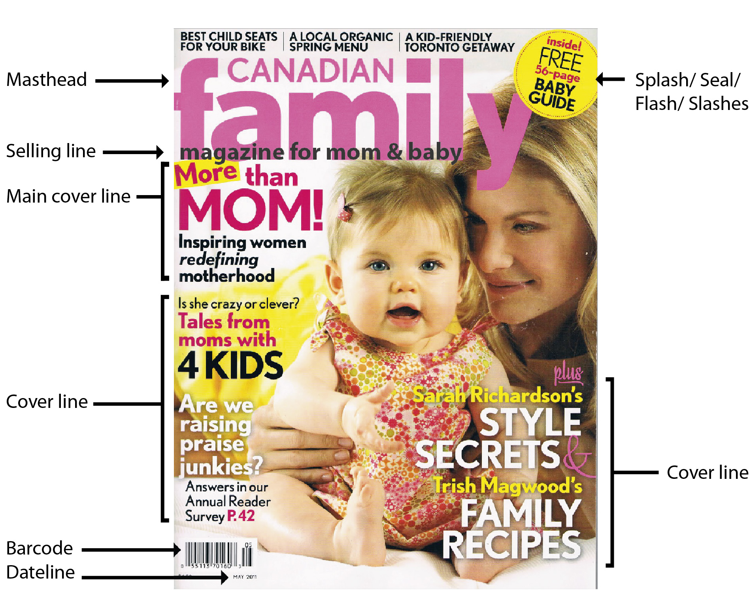
宣傳/蓋印/訊息/修訂
封面文字
日期文字
條碼
封面文字
主要封面文字
賣點文字
雜誌標題

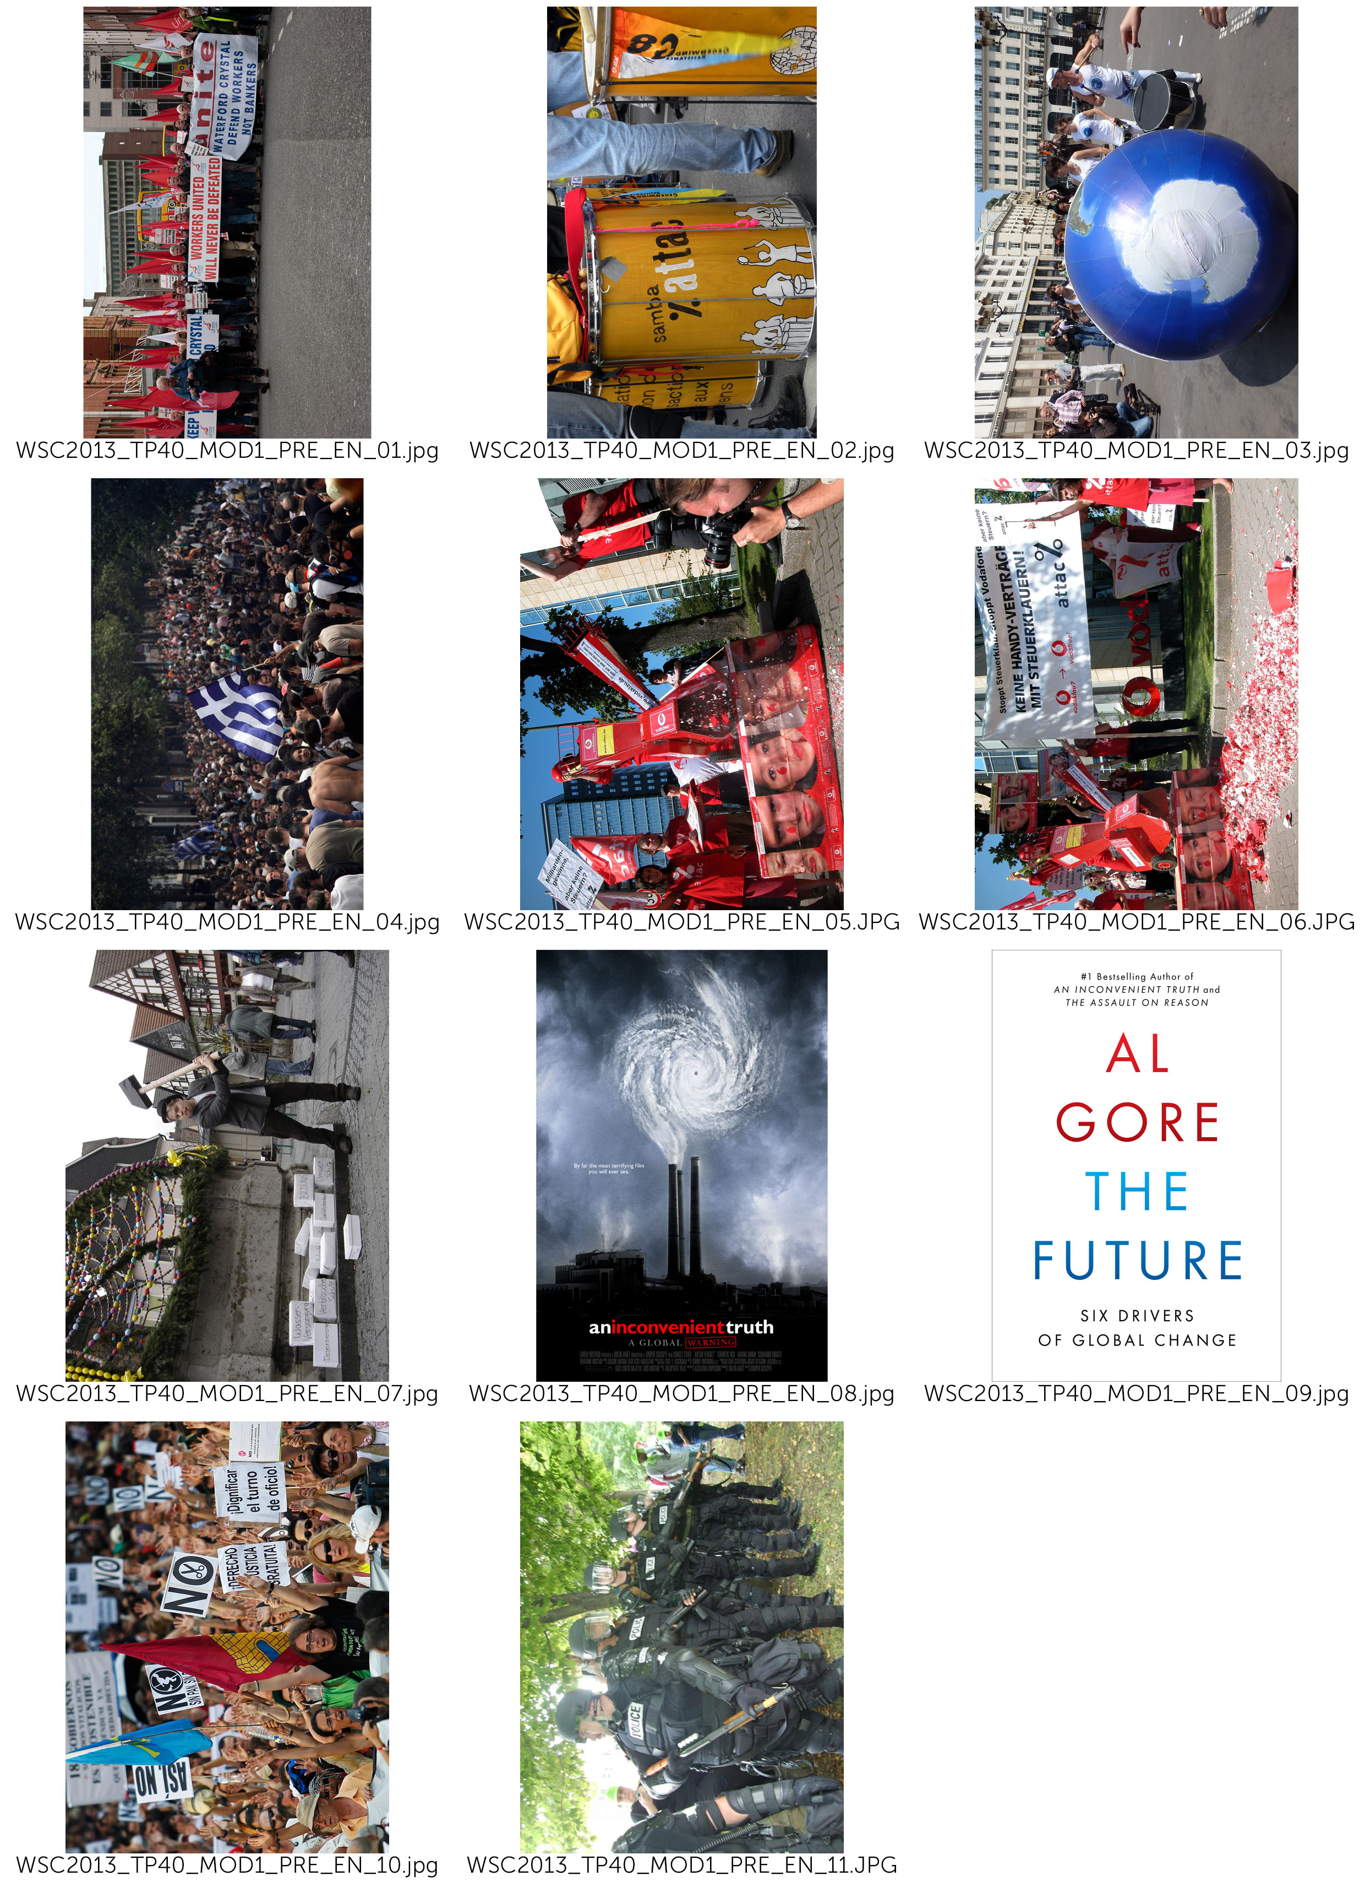
(- COVER)（－封面）

(use picture at your choice:
- WSC2013_TP40_MOD1_PRE_EN_01.jpg
- WSC2013_TP40_MOD1_PRE_EN_02.jpg
- WSC2013_TP40_MOD1_PRE_EN_03.jpg)

（選擇你要的圖片：
- WSC2013_TP40_MOD1_PRE_EN_01.jpg
- WSC2013_TP40_MOD1_PRE_EN_02.jpg
- WSC2013_TP40_MOD1_PRE_EN_03.jpg）

(– Masthead )（－雜誌標題）

SPANNER in the works

(– Selling Lines )（－賣點文字）

News magazine of ATTAC network

新的ATTAC網絡雜誌

(– Main Line Cover)（－主要封面文字）

Global Tax Justice:
If everybody shares the burden, no one suffers
全球課稅的正義：
如果每個人都分攤負荷，就沒有人會痛苦

(– Cover Lines)（－封面文字）

Fiscal and Economic Union
The Future by Al Gore
For a Europe-wide coordinated levy on wealth
財政與經濟統一
Al Gore的未來
與歐洲相配的財富徵收

(– Date Line)（－日期文字）

17 August 2013
2013年8月17日

(– Splash/ Seal/ Flash/ Slashes )（－宣傳/蓋印/訊息/修訂）

SPECIAL EDITION
特刊

(– Back Cover)（－封底）

(use picture:
- WSC2013_TP40_MOD1_PRE_EN_07.jpg)
（使用圖片：
- WSC2013_TP40_MOD1_PRE_EN_07.jpg）

( Title: )（標題：）

We fight for
我們抗爭

( Main text: )（主要文案：）
Attac sees the domination of financial markets on society as the main obstacle to the shift to a new mode of development that would be social, ecological, democratic, and relying on solidarity. In order to bring this domination to an end we demand:
Attac看見金融市場的壟斷是最主要的阻礙之一，為了這個模式，一個新的發展模式：社會、經濟、外交和對團隊依賴繼而產生。為結束這個壟斷，我們認為：

• Limits to capital flow and regulations such as a tax on financial transactions so as to drastically reduce all speculative moves.
• The socialization of the banking sector so that the banks’ investment policies will be governed by social and ecological imperatives and not by short-term profits.
• The prohibition of any capital transit via tax havens to put an end to occult financial activities and to tax evasion.
• Restrictions to TNCs through international regulations.
• The cancellation of the public debt of developing countries.
• An increase in taxes on financial incomes and on private estates;
• A fair organization of international trade that is favourable to developing countries, wage earners, and the environment.
• Access to common goods of humankind (water, education, healthcare…) so that human rights are adhered to.
• Global taxes to finance access to common goods, namely taxes on TNC profits, polluting activities (carbon tax), on financial transactions, on large private estates.
• A social and ecological agriculture without GM, respectful of the principle of food sovereignty and making it possible for peasants to earn a decent living both in the North and in the South.
• Ways of solving conflicts peacefully (Attac favours non violence in its actions).
Attac also fights any extension of commodification, whether through privatization of public services, the development of pension funds, the privatization of social security, speculation on the right to pollute through a carbon market.

（以上為編輯內文文字）
以上條列為Attac的主張，來爭取公平的權利：如成立國際交易的平等組織、提供好的商品給人類、設計全球稅收來徵收私有利益或對人類不利的事物等等。
Attac也為任何商品擴張的爭取，不論從公共服務私有化、退休金基金發展、社會安全的私有化、投機的污染排放碳的權利。

(– Master Pages)（－主頁）

SPANNER in the works

(– Page numbers )（－頁碼）

3, 8, 9, 10, 11

(– Spine )（－書背）

SPANNER in the works

17 August 2013

(– PAGE 3)（－第三頁內容）

(Title: )（標題：）
Our ideas
我們的想法

(Main text: )（主要文案：）
Attac is a movement opposing neo-liberal globalization
Neo-liberal globalization, based on the ‘liberalization’ of trade and financial markets, started at the end of the 1970s and has led to the total domination of financial markets on society as a whole. It is an instrument designed to further the enrichment of a tiny minority of investors at the expense of the rest of the population and the planet. Its effects are detrimental to.
Attac是一個反對新國際自由主義的運動
新國際自由主義，利基於「自由化」的貿易和經濟市場，開始於1970年代末期，並且全權主導金融市場。這是一個手段，讓世界其他人的支出圖利少數投資客，而這些影響損害了：

Social rights / 社會權利

neo-liberal globalization facilitates the shipping of businesses and jobs out of the country and fosters the worldwide competition between workers and, consequently, their precarization ;
It covers up tax evasion thanks to tax havens and sets in motion the competition between national tax systems and thus the reduction of public services.

（以上為編輯內文文字）
新國際自由主義將商業與工作運輸至其他國家，以及支配世界的商業競爭。由於逃稅天堂，以致於收不到稅，而減少了對公共服務的建設。

The planet / 這個星球

Neo-liberal globalization makes it possible for transnational companies to spread their production on the surface of the globe based solely on costs, so that the various parts of a product can be manufactured at different locations on the planet, generating thousands of miles of transport;
It sets up a competition between national environmental regulations and thus pushes them to the lowest possible level;
It tends to commercialize all aspects of society and thus extends endlessly the consumer and growth society.

（以上為編輯內文文字）
新國際自由主義促使跨國公司將他們的商品傾銷，並且為了讓商品價格單一化，他們將產品拆成很多部分，分別送到不同國家製造。讓價格可以壓至最低。這個趨勢使社會許多面向永無止境的商業化。

North South solidarity / 南北一致

As it organizes tax evasion, neo-liberal globalization imposes a new form of colonialism through corruption of elites in countries of the South;
Through free trade it imposes competition between farmers in the South and the large agro-business owners of the North ;
Via the debt mechanism, it allows the World Bank and the IMF to impose massive deregulation policies on developing countries.

（以上為編輯內文文字）
當一群逃稅者組織在一起時，新國際自由主義迫使一個新的複製模式出現。透過自由貿易，迫使南方的農夫必須與北方的企業化農場相競爭。而從負載的機制裡，世界銀行和IMF
被迫解除許多開發中國家政治上的限制。

Democracy / 民主政治

WTO, IMF, World Bank and the European Union set up new global economic rules outside any democratic debate: most international negotiations on trade or financial regulation occur away from the people; Neo-liberal globalization promotes the concentration of information dissemination in the hands of a few media and internet conglomerates.
The commercialization of all spheres of society reduces people to mere consumers at the expense of their citizenship.
And so, over the past 30 years we have witnessed a substantial enrichment of capital holders to the detriment of the vast majority of wage earners, together with a continued deterioration of the condition of our planet.
In the OECD countries, the proportion of wage earners in the producing sectors has declined by 10% while the return to capital has risen since the mid-1970s. In the United States, for instance, 60% of the growth recorded since 1980 has been captured by the wealthiest 1%.

（以上為編輯內文文字）
WTO, IMF, 世界銀行和歐盟在其他任何的外交債務以外設立一個新的全球經濟規則：大部分的貿易協商或金融債務與人們疏離；新國際自由主義主張將資訊集中在少數的媒體與網路手中。經濟金融都掌握在少數人手中。

(Caption for the pictures in this article : use picture at your choice:
- WSC2013_TP40_MOD1_PRE_EN_03.jpg
- WSC2013_TP40_MOD1_PRE_EN_05.jpg
- WSC2013_TP40_MOD1_PRE_EN_06.jpg)
（這篇文章的圖說：你自己選擇圖片：
- WSC2013_TP40_MOD1_PRE_EN_03.jpg
- WSC2013_TP40_MOD1_PRE_EN_05.jpg
- WSC2013_TP40_MOD1_PRE_EN_06.jpg）

Neo-liberal globalization promotes the concentration of information dissemination.
新國際自由主義提倡集中資訊的傳播

(– Pages 8 and 9)（－第8頁和第9頁）

(Title: )（標題：）
Global Tax Justice:
If everybody shares the burden, no one suffers.
全球課稅的正義：
如果每個人都分攤負荷，就沒有人會痛苦

(Main text: )（主要文案：）

How did this come about? / 這如何造成？

In the sixties and seventies capital was not very mobile, a tight net of capital transfer controls hampered the free flow of the deutschemark, schilling, pound etc. Due to this limited opportunities for capital flight taxation was reasonably fair. At this time the economy boomed, it grew faster than in the previous twenty years, full employment was close by and the differences in incomes began to shrink slowly. This scenario changed at the end of the seventies when neo-liberal politics like Thatcherism and Reaganomics got established worldwide. One of the core elements of neo-liberalism is the free flow of capital, but once capital is totally free to move it is difficult for Finance Ministers to tax it accordingly.

（以上為編輯內文文字）
當六十和七十個外資都不移動，緊縮的外資轉移控制了馬克、西令、磅等等的自由外資的流動。因為這個機會限制公平的外資流動。

More and more Tax Havens / 更多的免稅天堂

It gets even more difficult when, in the course of liberalisation, tax havens appear. You find tax havens not only in the Caribbean or Pacific (Bahamas, Samoa) but also right in the middle of Europe - Luxembourg, Liechtenstein, Monaco, Switzerland and Austria. In tax havens capitals gains and financial wealth are not only save from taxation, but the financial authorities in the countries of origin don´t get informed because of bank secrecy. The result is that the profiteers of globalisation contribute less and less to our common goods - hospitals, education, public transport, environmental protection, sport and culture.
（以上為編輯內文文字）

Tax Competition Begins / 稅收競爭開始

Tax havens not only attract tax evaders, they also put pressure on other countries to reduce their tax rates on income, profit and wealth. In the last twenty years almost all countries have been competing in reducing taxes on income, profits, and capital gains. In the industrialised countries the average tax on business profits has dropped from 51% to 35% since 1985. Tax on interest yield from 47% to 33% and the top income tax bracket plummeted from 52% to 42%, and this process is by no means at an end. Indeed some economists consider that in the long run it won't be possible to tax profits at all. For some multinational corporations this is already the case - they file their profit tax returns in tax havens, they use tax loopholes or sometimes even manipulate their balance sheets. The result is they pay little or no tax where they are actually operating. Some examples for Austria: Creditanstalt (1998 and 99) the Spar AG (1997 and 98) and Shell Austria (1977) or the Immuno AG (1977). This is not just unfair for the community, but also for the small and midium sized businesses that can´t use these 'creative possibilities' and suffer under an unfair competitive disadvantage.
（以上為編輯內文文字）

(Caption for the pictures in this article : use picture at your choice:
- WSC2013_TP40_MOD1_PRE_EN_01.jpg
- WSC2013_TP40_MOD1_PRE_EN_02.jpg
- WSC2013_TP40_MOD1_PRE_EN_03.jpg)
（這篇文章的圖說：你自己選擇圖片：
- WSC2013_TP40_MOD1_PRE_EN_01.jpg
- WSC2013_TP40_MOD1_PRE_EN_02.jpg
- WSC2013_TP40_MOD1_PRE_EN_03.jpg）

One of the core elements of neo-liberalism is the free flow of capital.
自由外資的流動是新國際自由主義中最核心的元素之一。

(- INFOGRAPHIC)（－信息設計）

(title)（標題）
Reduction of tax rates on income, profit and wealth In the industrialised countries
減少工業化國家收入、營利和財富的稅率

(text)（文案）
The average tax on business profits has dropped
51% to 35%
商業營收的平均稅收已經
從51% 降至 35%

Tax on interest yield
47% to 33%
獲利的稅收
從47% 降至 33%

The top income tax bracket plummeted
52% to 42%
最高的收入稅收驟跌
從52% 降至 42%

(caption for infographic)（信息設計的圖說）
Since 1985
從1985

( -TABLE)（－表格）

(title)（標題）
The multinational corporations who pay little or no tax
跨國公司繳很少的稅甚至不用繳稅

(text)（文案）
Company Year
Creditanstalt 1998,1999
Spar AG 1997, 1998
Shell Austria 1977
Immuno AG 1977
公司名稱 年份
Creditanstalt 1998,1999
Spar AG 1997, 1998
Shell Austria 1977
Immuno AG 1977

(caption for table)（表格的說明）
Some examples for Austria
奧地利的一些範例

(– Pages 10 and 11)（－第10頁和第11頁）

(Title: )（標題：）

The Future by Al Gore – review.
《未來》Al Gore（高爾）著－回顧

(Main text: )（主要文案：）

Al Gore's alarming new guide to what needs to change in world politics is essential reading
（Al Gore（高爾）對世界政治宣佈需要改變的新指標，為必讀的一本書）
According to reliable reports, the new leadership in Beijing has been reading Alexis de Tocqueville. It's not hard to see why China's elite might look for guidance to the aristocratic French thinker. In his classic text The Ancien Regime and the Revolution (1856), de Tocqueville wrote that the danger of revolution is not greatest in the depths of poverty and despair but when conditions have been improving – especially if some are benefiting far more than others. The relevance of this for China is obvious. The implications for policy are rather less so, since de Tocqueville also warned that for a bad government, the moment of greatest danger comes when it starts to reform. In such circumstances, repression might be a more prudent course of action. This troubling ambiguity could explain why Chinese readers, struggling to decipher the intentions of their rulers, made de Tocqueville's book a national bestseller.
From a parochial British perspective, what might be most significant is the fact that China's rulers are reading de Tocqueville at all. It is difficult to imagine David Cameron devoting any time to a 19th-century thinker. Along with much of the political class, the prime minister seems resistant to the notion that history has anything to teach, and looks for guidance to writers who extol the wisdom of crowds, explain the momentous importance of tipping points or pass on the revelation that humans are social animals – the fleeting nostrums of the airport bookstore. But if our rulers will not read the classics then they must read Al Gore, who, after eight years of reading and thinking, has produced a guide for the politically perplexed that will surely endure.
（以上為編輯內文文字）

(Caption for the pictures in this article : use picture at your choice:
- WSC2013_TP40_MOD1_PRE_EN_08.jpg
- WSC2013_TP40_MOD1_PRE_EN_09.jpg)
（這篇文章的圖說：你自己選擇圖片：
- WSC2013_TP40_MOD1_PRE_EN_08.jpg
- WSC2013_TP40_MOD1_PRE_EN_09.jpg）

The Cover of Al Gore’s Book, The future
Al Gore這本書的封面，未來

(Title: )（標題：）

For a Europe-wide coordinated levy on wealth
與歐洲相配的財富徵收

(Main text: )（主要文案：）

The nature of the crisis（危機的本身）
A constantly increasing disparity of wealth is an intrinsic aspect of capitalism. Wealth grows faster than workers’ income. Large amounts of wealth grow faster than small amount. In some countries, wealth taxes exist. But the tax rates are much lower than the growth rates of large fortunes. Therefore, strong political correctives to create a fairer distribution are necessary. This applies even more in the currently dominant form of capitalism driven by financial markets, since here the disparity in the distribution of prosperity has been growing especially rapidly. As this polarization of the distribution of wealth grows, so does the amount of capital circulating around the world in search of profitable investment opportunities. In particular since the 1970s, this mass has increased dramatically. It became less and less possible to exploit this capital profitably in the productive economy. In the search for new sources of profit, the international financial markets became more and more important. This transition was accompanied and fostered by constantly increasing deregulation and globalization of the financial markets, and led to a quite novel dynamism involving the polarization of the distribution of income and assets. The increasing dominance of the financial markets has allowed gigantic profits – and also losses – to be made within seconds. Thus the system is becoming more and more unstable. More and more speculative bubbles develop, which must burst sooner or later.
（以上為編輯內文文字）

(Caption for the pictures in this article : use picture at your choice:
- WSC2013_TP40_MOD1_PRE_EN_10.jpg
- WSC2013_TP40_MOD1_PRE_EN_11.jpg)
（這篇文章的圖說：你自己選擇圖片：
- WSC2013_TP40_MOD1_PRE_EN_10.jpg
- WSC2013_TP40_MOD1_PRE_EN_11.jpg）

A constantly increasing disparity of wealth is an intrinsic aspect of capitalism

財富不對等持續增長是資本主義的一個本質

(Title: )（標題：）

Fiscal and Economic Union
公債與經濟統一

(Main text: )（主要文案：）

Fiscal pact, ESM, six-pack, two-pack (公債協議、ESM、六項、二項)
Under the pressure of the crisis, the powerful are pushing through their murky "reform" measures at a rapid pace. The logic is always the same: Reduce debts through cuts in social services and privatisation, raise competitiveness through wage cuts and eliminate workers rights. The consequences: A deep recession, further aggravating the economic crisis. In southern Europe the 'Troika' of the ECB, EU Commission, and the IMF dictate one so called Memorandum (austerity package) after another. The reality is a devastating social crisis. Mass unemployment, poverty, homelessness, soaring crime and waves of suicides are once again part of European everyday life. And "coincidentally" our democracies are being hollowed out: highly indebted countries are forced to transfer their sovereignty from their elected parliaments to the EU. Every day, the technocrats of the EU Commission and the ECB gain yet more power for themselves.
Can things get even worse, after all the reform packages so far that have established a neo-liberal, anti-democratic politics throughout Europe? Yes they can. In the European Council the introduction of a fiscal and economic union is being prepared right now. The diktat of austerity, through which Greece, Spain and Portugal suffer right now, will be institutionalised on the European level. Or as the European Commission President Barroso put it: A quiet revolution has been taking place.
（以上為編輯內文文字）

(Caption for the pictures in this article : use picture:
- WSC2013_TP40_MOD1_PRE_EN_04.jpg)
（這篇文章的圖說：你自己選擇圖片：
- WSC2013_TP40_MOD1_PRE_EN_04.jpg）

In the European Council the introduction of a fiscal and economic union is being prepared.
歐洲委員會準備進行公債和經濟的整合

